Ideation Phase
Brainstorm & Idea Prioritization Template
D ate | 30 /10/ 2025
Team ID | NM2025TMID06312
Project Name | Educational Organisation Using ServiceNow
Maximum Marks | 100 Marks
What is School Brainstorming?
Brainstorming: Creating Amazing ServiceNow Ideasl
Brainstormingis like having a free and open idea party e that encourages everyone—students, teachers, and the IT team—to join in the creative thinking! This process leads directly to solving the service problems the school faces.
The Golden Rules for Great Ideas:
  Rule
  olume Over alue
  hat it Means for Our ServiceNow Project
row out TONS of ideas (volume) first! Don't worry if they are good or bad vet (value). We want quantity!
Id and unique ideas are WELCOME! Maybe the school needs a "Help Robot" or a pecial app that sings when your request is finished! No idea is too silly to start with_


 | la borate nd Build | Everyone is encouraged to work together and help each other make their ideas even better. If one person suggests a "Help Button," another person can build on it by uggesting the Button glows green when it's done!"
using the Idea Template
In Our team has use a template (like a digital whiteboard or a piece of paper) in our brainstorming sessions to quickly unleash your imagination and start shaping concepts Even if the students. teachers, and IT team aren't sitting in the same room. this shared space helps everyone collaborate to develop a rich amount of creative solutions for the ServiceNow platform !
Ref Link:
https://app.mura . co/t/educatio nai organisationusing8461/m/educationalorganisationusing84G1/17618 00598369/5ac1aogg1aa83168c8e1e85g4gd5e14Ba6f3433S

Step-I: Team Gathering, Collaboration and Select the Problem Statement
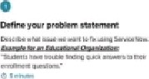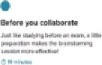
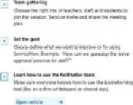

Educational
Organization using 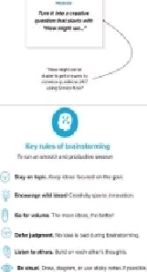
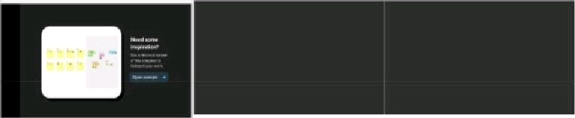

Step-2: Brainstorm, Idea Listing and Grouping
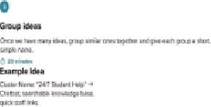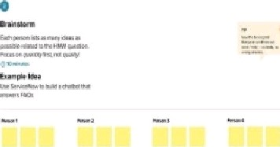

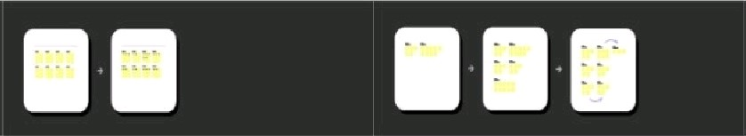

Step-3: Idea Prioritization
Picking the Best Ideas (Step 구 Prio『itization)



콤 협 협 콤

